Help Support Our Last Fundraiser For The School Year.

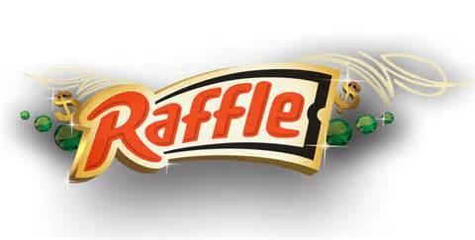
St. Peter’s School
50/50 Cash Raffle
And
Family Pasta Dinner
Raffle Books And Family Pasta Dinner Tickets Are Available In The School Office And In The Rectory.
Raffle Tickets Are
$10.00 A Ticket Or
$50.00 For A Book Of 5
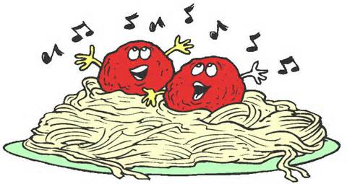 Pasta Dinner Tickets Are
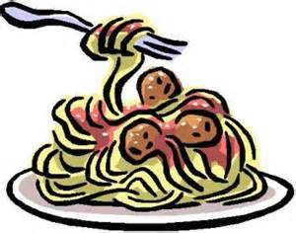
$5.00 Per Child and $10.00 Per Adult
Join us for a night of good food and fun
Friday, May 15th
The Drawing Will Be Held
During The Family Pasta Night.
School Cafeteria @ 6:00 PM


