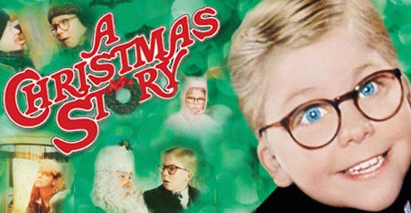
Saint Peter’s School welcomes you to join us for…
Christmas Movie Night
Come Join Us…
Bring your own blankets and pillows or lawn chairs. You can cozy up with the family and enjoy A Christmas Story on the big screen.
We will be serving hotdogs, chips, and soda.
We hope to see you there. It will be cold out so come and warm up with a good flick and some yummies!
Stop by the front office to pick up your tickets.

When: Friday, December 18, 2015
Where: School Gym
Cost: $8.00 per person*

*Price includes two hotdogs, a bag of chips, and a bottle of water or can of soda.
Come and enjoy a night of snacks and a movie.
We will be showing the classic Christmas must-see movie…

