On Wednesday St. Peter’s School held its annual National Junior Honor Society induction ceremony. Congratulations to our new members! Thank you to Mrs. Bubenik and Mrs. Reese, advisors.
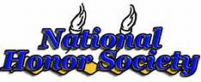

Fourth Grade
Jarvin Mendoza

Fifth Grade
David Betancur
Andrew Cuenca
Brianna Garcia
Christopher Melendez
Marcela Toledo

Sixth Grade
Matthew Perez
Emmalis Diaz

Seventh Grade
Natalia Coba
Amanda Klein
Joel Melendez
Mathew Munoz
Anjianie Perez

Eighth Grade
Chiarize-Crish Bulusan
Lyonnel Eugene

