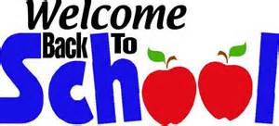
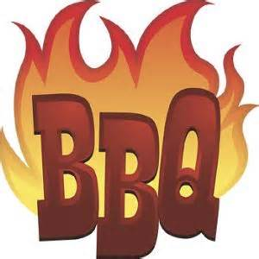
Join us for a Welcome Back to School Barbecue
Tuesday, August 25, 2015
St Peter’s School
1:00 PM
St. Peter’s Students, Families, Staff and Parish



The cost is $8.00 per child and $12.00 per adult

Join us for an afternoon of good food and fun!!
Please bring lawn chairs and/or blankets.
This will be a great opportunity for everyone to greet each other and meet our new faculty members, new students and their families.
We look forward to seeing you at the BBQ.

Contact The School Office For More Information – 973-759-3143

